Tunbridge Wells Conservative Association
Sherwood Branch

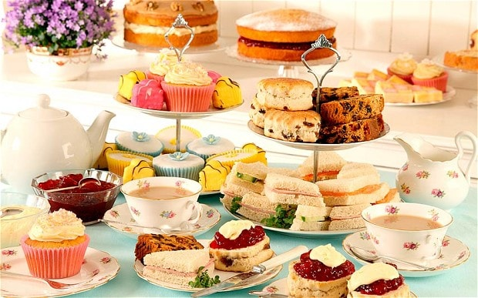
Come and have afternoon tea with a glass of Summer punch on Sunday September 3rd at 4pm in Thelma’s garden at Littledene .
£10 per person.
All welcome. There will be a raffle

Please complete the tear off slip below and return to:-
Mrs Thelma Huggett Littledene Liptraps Lane Tunbridge Wells, Kent TN2 3AB

01892-532928 email: thelmarhuggett@gmail.com
Cheque receipt will be acknowledged by phone or email.
…………………….……………………………………………………………………………………

I/We would like ………..places for tea on Sunday 3rd September 2017

I/We enclose a cheque for £…………… payable to TWCA.

Name(s)……………………………………………………………………………………………

Tel…………………………………..email………………………………………..……………..

